MAJOR PROJECT - 21CSP401L
Text Mining and Sentiment Analysis Based Intelligent System for Monitoring and Evaluating Public Health Awareness Campaigns

A PROJECT REPORT

Submitted by

RATAKONDA MOKSHAGNA [RA2211026050011]

T DYANA VARDHAN REDDY [RA2211026050024]

Under the guidance of

Dr. C. PRIYADHARSINI
(Assistant Professor, Department of Computer Science & Engineering)

in partial fulfillment for the award of the degree of

BACHELOR OF TECHNOLOGY
in

COMPUTER SCIENCE ENGINEERING WITH SPECIALIZATION IN ARTIFICIAL INTELLIGENCE AND MACHINE LEARNING
of

FACULTY OF ENGINEERING AND TECHNOLOGY



SRM Nagar, Trichy-Chennai Highway, Tiruchirappalli - 62115

MAY 2026

SRM INSTITUTE OF SCIENCE AND TECHNOLOGY TIRUCHIRAPPALLI

BONAFIDE CERTIFICATE

Certified that this project report titled “TEXT MINING AND SENTIMENT ANALYSIS BASED INTELLIGENT SYSTEM FOR MONITORING AND EVALUATING PUBLIC HEALTH AWARENESS CAMPAIGNS” is the bonafide work of “RATAKONDA MOKSHAGNA [RA2211026050011], T DYANA VARDHAN REDDY [RA2211026050024]”, who carried out the project under my supervision. Certified further, that to the best of my knowledge the work reported herein does not form any other project report or dissertation on the basis of which a degree or award was conferred on an earlier occasion on this or any other candidate.

SIGNATURE

Dr. C. Priyadharsini

GUIDE
Assistant Professor
Department of Computer Science & Engineering

Signature of the Internal Examiner

SIGNATURE

Dr. R. Balaji Ganesh

HEAD OF THE DEPARTMENT
Department of Computer Science and Engineering w/s AIML

Signature of the External Examiner

Abstract
Public health awareness campaigns play a crucial role in disseminating accurate information and influencing public behavior, especially during health crises. With the rapid growth of social media platforms, large volumes of user-generated textual data are continuously produced, reflecting public sentiment as well as the spread of misinformation. Analyzing this data is essential for evaluating the effectiveness of health campaigns and identifying potential risks associated with misleading information.
This project presents a comprehensive system for text mining and sentiment analysis of public health-related content using machine learning and deep learning techniques. The proposed system utilizes a Long Short-Term Memory (LSTM) model for sentiment classification and a TF-IDF-based Logistic Regression model for misinformation detection. In addition, the system incorporates engagement-based analysis, time-series trend detection, and spike detection to identify sudden changes in public perception. A Streamlit-based web application is developed to provide real-time analysis, interactive dashboards, and policy recommendations for decision-makers.
Experimental results demonstrate that the system achieves high accuracy in sentiment classification and effectively detects misinformation patterns. The proposed approach provides a scalable and practical framework for monitoring public opinion and improving the effectiveness of public health awareness campaigns.

TABLE OF CONTENTS
Abstract 3
TABLE OF CONTENTS 4
ABBREVIATIONS 5
1. Introduction 6
1.1 Introduction Overview 6
1.2 Problem Statement 6
1.3 Objectives 7
1.4 Scope 7
1.5 Innovation 8
2. Literature Survey 9
2.1 Literature Overview 9
2.2 Literature Survey 9
3. System Analysis 111
3.1 System Overview 111
3.2 Input Features 112
3.3 Prediction Model 122
3.4 Datasets 133
3.5 System Requirements 134
3.6 Constraints and Assumptions 145
4. System Design 166
4.1 System Architecture 166
4.2 Workflow 177
4.3 Tools and Technologies 21
4.4 User Interface 212
4.5 Data Flow Diagram 234
4.6 Scalability Considerations 245
4.7 Security and Privacy 256
5. Coding and Testing 277
5.1 Coding 277
5.2 Testing 278
5.3 Performance Analysis 28
5.4 Error Analysis 29
5.5 Test Cases 300
5.6 Challenges Faced 311
5.7 Validation Metrics 322
6. Conclusion 344
6.1 Limitations 344
6.2 Social Impact 355
7. Future Enhancements 366
7.1 Technical Enhancements 366
7.2 User Experience Enhancements 366
7.3 Long-Term Vision 377
8. References 388

ABBREVIATIONS

Abbreviation | Full Form
AI | Artificial Intelligence
NLP | Natural Language Processing
ML | Machine Learning
DL | Deep Learning
LSTM | Long Short-Term Memory
TF-IDF | Term Frequency–Inverse Document Frequency
API | Application Programming Interface
CSV | Comma-Separated Values
KPI | Key Performance Indicator
UI | User Interface
GPU | Graphics Processing Unit

1. Introduction

1.1 Introduction Overview
Public health awareness campaigns are essential for promoting healthy behaviors, preventing diseases, and ensuring the dissemination of accurate medical information. In recent years, the widespread use of social media platforms has significantly transformed how information is shared and consumed. Platforms such as Twitter and other online forums have become major sources of public opinion, where individuals express their views, experiences, and concerns related to health issues. While this provides valuable insights into public perception, it also creates challenges due to the rapid spread of misinformation and varying sentiments.
Understanding public sentiment toward health campaigns is critical for evaluating their effectiveness and identifying areas that require improvement. Traditional methods such as surveys and interviews are often limited in scale and time-consuming. In contrast, text mining and natural language processing (NLP) techniques enable automated analysis of large volumes of user-generated content in real time. Sentiment analysis helps classify opinions into positive, negative, or neutral categories, while misinformation detection identifies potentially harmful or misleading content.
This project focuses on developing an intelligent system that combines machine learning and deep learning techniques to analyze public sentiment and detect misinformation related to health campaigns. A Long Short-Term Memory (LSTM) model is used for sentiment classification due to its ability to capture contextual dependencies in textual data. Additionally, a TF-IDF-based Logistic Regression model is implemented to identify misinformation patterns. The system also incorporates engagement-based analysis, trend detection, and visualization through an interactive web application.
The primary objective of this project is to provide a scalable and practical solution that can assist policymakers and public health authorities in monitoring public opinion, identifying misinformation trends, and improving the effectiveness of awareness campaigns. By leveraging data-driven insights, the system aims to support informed decision-making and enhance the impact of public health initiatives.

1.2 Problem Statement
Public health awareness campaigns are designed to educate people and promote healthy behaviors, especially during critical situations such as pandemics. However, with the rapid growth of social media platforms, public opinion is highly dynamic and difficult to monitor using traditional methods. Large volumes of user-generated content are continuously produced, making it challenging for health authorities to understand how people perceive these campaigns.
One of the major issues is the presence of misinformation, which spreads quickly and can negatively influence public behavior. False or misleading health information can reduce trust in official guidelines, leading to poor decision-making and decreased effectiveness of awareness campaigns. At the same time, public sentiment toward health initiatives may vary widely, and identifying negative perceptions early is crucial for timely intervention.
Existing approaches to analyzing public opinion are often limited in scalability, lack real-time capabilities, or focus only on a single aspect such as sentiment analysis without considering misinformation. Moreover, there is a lack of integrated systems that can simultaneously analyze sentiment, detect misinformation, track trends over time, and present insights in an understandable manner.
Therefore, there is a need for a comprehensive and automated system that can analyze large-scale textual data from social media, accurately classify public sentiment, detect misinformation, and provide actionable insights. Such a system can assist policymakers and public health authorities in monitoring public perception, identifying emerging issues, and improving the effectiveness of health awareness campaigns.

1.3 Objectives
The primary objective of this project is to develop an intelligent system for analyzing public sentiment and detecting misinformation related to public health awareness campaigns using text mining and machine learning techniques.
The specific objectives of the project are as follows:
- To collect and preprocess large-scale social media data related to public health campaigns.
- To design and implement a sentiment analysis model using Long Short-Term Memory (LSTM) to classify public opinion into positive, negative, and neutral categories.
- To develop a misinformation detection model using TF-IDF and Logistic Regression to identify misleading or false information.
- To perform engagement-based analysis by incorporating metrics such as retweets and likes to measure the impact of public opinion.
- To analyze temporal trends and detect sudden spikes in negative sentiment and misinformation using statistical methods.
- To develop an interactive web application using Streamlit for real-time analysis and visualization of results.
- To provide actionable insights and policy recommendations that can assist public health authorities in improving campaign effectiveness.

1.4 Scope
The scope of this project focuses on developing a data-driven system for analyzing public sentiment and detecting misinformation related to public health awareness campaigns using social media data. The system is designed to process large-scale textual data, primarily from Twitter datasets, and provide meaningful insights into public perception.
The project covers the application of text mining, natural language processing, and machine learning techniques to classify sentiment and identify misinformation in user-generated content. It includes the implementation of a deep learning-based LSTM model for sentiment analysis and a TF-IDF-based Logistic Regression model for misinformation detection. Additionally, the system incorporates engagement metrics such as retweets and likes to evaluate the influence of public opinion.
The scope also includes time-series analysis to monitor trends and detect sudden spikes in negative sentiment and misinformation. An interactive web application is developed using Streamlit to enable real-time analysis, visualization of results, and generation of policy recommendations for decision-makers.
However, the project is limited to text-based analysis and does not include multimedia data such as images, videos, or audio. It primarily focuses on English-language datasets and does not incorporate multilingual support. Furthermore, the system uses pre-collected datasets rather than real-time data streaming from social media APIs. Despite these limitations, the project provides a scalable and practical framework that can be extended in future work to include real-time data processing, multilingual capabilities, and advanced deep learning models.

1.5 Innovation
The proposed system introduces a novel and integrated approach to analyzing public health awareness campaigns by combining multiple analytical components into a single framework. Unlike traditional systems that focus only on sentiment analysis, this project integrates sentiment classification, misinformation detection, trend analysis, and decision support within a unified platform.
One of the key innovations of this work is the use of a hybrid modeling approach, where a deep learning-based LSTM model is employed for sentiment analysis, while a machine learning-based TF-IDF with Logistic Regression model is used for misinformation detection. This combination leverages the strengths of both deep learning and classical machine learning techniques, improving overall system performance and efficiency.
Another important contribution is the incorporation of engagement-based sentiment analysis. By considering metrics such as retweets and likes, the system evaluates not only the sentiment of the content but also its impact and reach. This provides a more realistic understanding of public opinion compared to traditional sentiment analysis methods that treat all data equally.
The project also introduces a time-series spike detection mechanism to identify sudden increases in negative sentiment and misinformation. This enables early detection of critical trends, allowing timely intervention by policymakers and public health authorities.
Furthermore, the development of an interactive web application using Streamlit enhances the practical usability of the system. The dashboard provides real-time analysis, visualizations, and policy recommendations, making the system accessible and useful for decision-making processes.
Overall, the innovation of this project lies in its integrated, scalable, and practical approach to combining advanced analytics with real-world applicability in the domain of public health awareness.

2. Literature Survey

2.1 Literature Overview
The rapid growth of social media platforms has transformed the way public health information is disseminated and consumed. During global health crises such as the COVID-19 pandemic, platforms like Twitter have become significant sources of public opinion, enabling large-scale analysis of user-generated textual data . This has created opportunities for monitoring public sentiment and identifying misinformation in real time, while also introducing challenges due to the high volume and variability of data.
Sentiment analysis is a key area of natural language processing that focuses on identifying the emotional tone of textual content. Early research in this field established fundamental techniques for classifying opinions into categories such as positive, negative, and neutral . Traditional machine learning approaches relied on feature-based models, while more recent advancements have leveraged deep learning architectures such as Long Short-Term Memory (LSTM) networks, which are capable of capturing contextual relationships in sequential data .
In parallel, misinformation detection has emerged as a critical research area, particularly during the COVID-19 infodemic, where false information spread rapidly across social media platforms . Machine learning techniques, including TF-IDF and classification models, have been widely used to identify misleading content based on linguistic patterns. Additionally, domain-specific keyword-based approaches have been shown to improve detection accuracy in health-related contexts .
Another important aspect of social media analysis is the use of engagement metrics such as likes and retweets to measure the influence of content. Studies have shown that highly engaged posts have a greater impact on public perception, highlighting the importance of incorporating engagement-based analysis into sentiment monitoring systems .
Overall, advancements in text mining, machine learning, and data visualization have enabled the development of systems capable of analyzing public opinion at scale. However, there remains a need for integrated solutions that combine sentiment analysis, misinformation detection, and real-time visualization to support decision-making in public health awareness campaigns.

2.2 Literature Survey
Several studies have explored sentiment analysis and misinformation detection in the context of social media data, particularly during the COVID-19 pandemic. Early work by Pak and Paroubek utilized Twitter data for sentiment classification using machine learning techniques such as Support Vector Machines, achieving approximately 82% accuracy, but lacked domain-specific focus . Nemes and Kiss applied Naive Bayes for sentiment analysis on COVID-19 tweets and reported an accuracy of around 84%, although their approach was limited to basic classification without real-time deployment .
Sharma et al. combined lexicon-based methods with Logistic Regression to analyze sentiment trends from social media data, achieving approximately 88% accuracy. However, their approach relied heavily on predefined sentiment lexicons and did not incorporate advanced deep learning models . Samuel et al. proposed an ensemble model combining LSTM and Convolutional Neural Networks, achieving improved accuracy of around 91%, but their work did not include misinformation detection or deployable systems .
More advanced approaches have utilized transformer-based models such as BERT for sentiment classification. Lamsal demonstrated that BERT-based models could achieve accuracy levels of around 93% on COVID-19 Twitter datasets, although these models require significant computational resources, limiting their applicability in real-time systems .
In the domain of misinformation detection, Alam et al. developed a machine learning model using multi-perspective annotations and achieved approximately 94% accuracy. However, their work focused solely on misinformation classification and did not integrate sentiment analysis or visualization tools . Other studies have highlighted the importance of engagement metrics and network-based analysis in understanding the spread of misinformation across platforms.
Despite these advancements, most existing studies focus on individual components such as sentiment analysis or misinformation detection in isolation. Very few systems provide an integrated framework that combines sentiment classification, misinformation detection, temporal trend analysis, and interactive dashboards. Additionally, many studies lack deployable solutions that can be used directly by policymakers.
This gap highlights the need for a comprehensive system that integrates multiple analytical components into a single platform, which forms the motivation for the proposed work.

3. System Analysis

3.1 System Overview
The proposed system is designed as an integrated framework for analyzing public sentiment and detecting misinformation related to public health awareness campaigns using social media data. It combines text mining, machine learning, and visualization techniques to transform raw textual data into meaningful insights that can assist policymakers and health authorities.
The system follows a pipeline-based architecture consisting of multiple stages. The process begins with data collection, where pre-existing Twitter datasets related to COVID-19 are used as the primary data source. These datasets contain information such as tweet text, timestamps, engagement metrics (retweets and likes), and location details.
In the next stage, data preprocessing is performed to clean and standardize the textual data. This includes removing unnecessary characters, handling missing values, converting text to lowercase, and tokenizing the text. The processed data is then transformed into numerical representations suitable for model training.
The core of the system consists of two analytical modules. The first module is the sentiment analysis component, which uses a Long Short-Term Memory (LSTM) deep learning model to classify text into positive, negative, or neutral sentiment. This model captures contextual relationships within the text, improving classification accuracy. The second module is the misinformation detection component, which uses TF-IDF feature extraction combined with a Logistic Regression classifier to identify misleading or false information.
To enhance the analysis, the system incorporates engagement-based evaluation, where metrics such as retweet count and favorite count are used to measure the influence of each tweet. This helps in identifying highly impactful content and provides a more realistic representation of public opinion.
The system also includes a trend analysis module, which performs time-series analysis to monitor changes in sentiment over time. A statistical approach is used to detect sudden spikes in negative sentiment and misinformation, enabling early identification of critical events or shifts in public perception.
Finally, the processed results are presented through a Streamlit-based web application, which provides an interactive dashboard for users. The dashboard includes features such as real-time sentiment prediction, visualization of sentiment distribution, trend analysis graphs, regional insights, and policy recommendations. This interface allows users to easily interpret the results and make data-driven decisions.
Overall, the system provides a scalable and practical solution for monitoring public sentiment and misinformation, integrating multiple analytical components into a single platform.

3.2 Input Features
The proposed system utilizes structured and unstructured data obtained from Twitter datasets related to public health awareness campaigns. These datasets contain multiple attributes that are used as input features for sentiment analysis, misinformation detection, and trend analysis.
The primary input feature is the textual content of the tweet, represented as clean_tweet. This feature contains the preprocessed version of the original tweet, where noise such as URLs, special characters, and stop words are removed. It serves as the main input for both the sentiment analysis model and the misinformation detection model.
The timestamp feature, represented as created_at, is used for temporal analysis. It enables the system to track changes in sentiment over time and identify patterns such as trends and spikes in negative sentiment or misinformation.
The system also incorporates engagement-related features, including retweet_count and favorite_count. These features are combined to compute an engagement score, which helps measure the influence and reach of a particular tweet. This allows the system to prioritize highly impactful content when analyzing public sentiment.
Another important feature is the location information, represented as place. This feature is used to perform regional analysis, enabling the system to identify geographical variations in sentiment and misinformation patterns.
Additionally, derived features such as sentiment labels (positive, negative, neutral) and misinformation indicators (true or false) are generated during the processing stage. These features are used for evaluation, visualization, and decision-making within the system.
Overall, the combination of textual, temporal, engagement, and geographical features enables the system to perform comprehensive analysis and provide meaningful insights into public health awareness campaigns.

3.3 Prediction Model
The proposed system employs a hybrid modeling approach that combines deep learning and machine learning techniques to perform sentiment analysis and misinformation detection on textual data. The prediction process consists of two primary models: a Long Short-Term Memory (LSTM)-based deep learning model for sentiment classification and a TF-IDF-based Logistic Regression model for misinformation detection.
The sentiment analysis model is built using an LSTM architecture, which is well-suited for processing sequential textual data. The input text is first converted into numerical sequences using a tokenizer, followed by sequence padding to ensure uniform input length. These sequences are then passed through an embedding layer that transforms words into dense vector representations. The LSTM layer processes these sequences and captures contextual dependencies within the text. Dropout layers are used to prevent overfitting, and fully connected dense layers are applied to perform classification. The final output layer uses a softmax activation function to classify the input text into three categories: positive, negative, and neutral. The model is trained using the Adam optimizer and sparse categorical cross-entropy loss function, ensuring efficient convergence and accurate predictions.
The misinformation detection model is implemented using a traditional machine learning approach. Textual data is transformed into numerical features using the Term Frequency–Inverse Document Frequency (TF-IDF) technique, which evaluates the importance of words relative to the dataset. These features are then fed into a Logistic Regression classifier, which performs binary classification to determine whether a given text contains misinformation. Logistic Regression is chosen due to its simplicity, interpretability, and strong performance in text classification tasks.
During the prediction phase, user input or dataset text is processed through both models simultaneously. The sentiment model outputs the emotional polarity of the text, while the misinformation model identifies whether the content is misleading or not. The combined results are then used for visualization, trend analysis, and decision-making.
This hybrid approach leverages the strengths of both deep learning and classical machine learning techniques, resulting in improved accuracy, efficiency, and scalability. It enables the system to perform real-time predictions while maintaining reliable performance across large datasets.

3.4 Datasets

The proposed system utilizes publicly available Twitter datasets related to COVID-19 to analyze public sentiment and detect misinformation in health awareness campaigns. These datasets provide large-scale, real-world textual data reflecting public opinion during different phases of the pandemic.
The study combines three separate Twitter datasets, each corresponding to a specific time period. The first dataset covers April to June 2020, representing the initial phase of the pandemic characterized by global lockdowns and uncertainty. The second dataset spans August to September 2020, capturing the period of partial reopening and the emergence of second-wave concerns. The third dataset includes data from April to June 2021, which reflects discussions around vaccination, new variants, and policy changes.
Each dataset contains multiple attributes, including:
- clean_tweet: Preprocessed textual content of tweets
- sentiment: Label indicating positive, negative, or neutral sentiment
- created_at: Timestamp of the tweet
- retweet_count: Number of retweets
- favorite_count: Number of likes
- place: Location information
After combining and preprocessing the datasets, duplicate records and missing values were removed to ensure data quality. The final dataset consists of hundreds of thousands of tweet records, providing sufficient data for training and evaluating machine learning models.
The dataset exhibits a moderately imbalanced distribution of sentiment classes, with neutral tweets forming the majority, followed by positive and negative tweets. This distribution reflects real-world social media behavior, where neutral informational content is more common.
These datasets are well-suited for the proposed system as they capture temporal variations in public sentiment, enabling trend analysis and spike detection. Additionally, the inclusion of engagement and location features supports advanced analytics such as influence measurement and regional analysis.
Overall, the dataset provides a comprehensive and realistic foundation for building and evaluating the sentiment analysis and misinformation detection models.

3.5 System Requirements
The implementation of the proposed system requires both hardware and software components to support data processing, model training, and web application deployment.
A. Hardware Requirements
The system can be developed and executed on a standard computing device with moderate specifications. The recommended hardware requirements are:
- Processor: Intel Core i5 or higher
- RAM: Minimum 8 GB (16 GB recommended for faster processing)
- Storage: At least 10 GB of free disk space
- GPU (Optional): NVIDIA GPU (for faster model training using platforms like Google Colab)
The system is also compatible with cloud-based environments such as Google Colab, which provides GPU support for training deep learning models efficiently.
B. Software Requirements
The system is developed using Python and various machine learning and web development libraries. The required software components include:
- Operating System: Windows / Linux / macOS
- Programming Language: Python (version 3.8 or above)
- Development Environment: Jupyter Notebook / Google Colab / VS Code
Libraries and Frameworks:
- TensorFlow / Keras: For building and training the LSTM model
- Scikit-learn: For TF-IDF vectorization and Logistic Regression
- Pandas & NumPy: For data manipulation and numerical operations
- Matplotlib / Plotly: For data visualization
- Streamlit: For developing the web application interface
- Joblib: For saving and loading trained models
C. System Requirements for Deployment
For deploying the web application, the following are required:
- Streamlit framework for hosting the application
- Web browser (Chrome, Edge, or Firefox)
- Internet connection for accessing the deployed application
Optional deployment platforms include:
- Streamlit Community Cloud
- Localhost deployment
- Cloud platforms such as AWS or Render
Summary
The system is designed to be lightweight and scalable, requiring only moderate hardware resources while supporting advanced machine learning functionalities. The use of widely available tools and libraries ensures ease of development, deployment, and future scalability.

3.6 Constraints and Assumptions
A. Constraints
The proposed system is subject to several limitations that may affect its performance and applicability:
- The system relies on pre-collected Twitter datasets and does not support real-time data streaming from social media APIs.
- The analysis is limited to text-based data and does not consider multimedia content such as images, videos, or audio.
- The models are trained primarily on English-language data, which restricts the system’s applicability to multilingual environments.
- The misinformation detection approach is partially keyword-based, which may fail to identify subtle or evolving misinformation patterns.
- The performance of the system depends on the quality and accuracy of the dataset labels, which may contain noise or bias.
- The system assumes structured input data with predefined columns, limiting flexibility when handling unstructured or incomplete datasets.
- Deployment using platforms like Streamlit may have performance limitations for very large datasets or concurrent users.
B. Assumptions
The input datasets are cleaned and preprocessed, with minimal missing or inconsistent values.
The sentiment labels provided in the dataset are accurate and reliable for training the model.
Users will provide input data in the expected format (e.g., CSV files with required columns).
Social media text reflects genuine public opinion, making it suitable for sentiment analysis.
Engagement metrics such as retweets and likes are assumed to be valid indicators of content influence.
The selected machine learning and deep learning models are assumed to be sufficient for capturing patterns in the given dataset.
The system operates in an environment with adequate computational resources for model loading and prediction.
Summary
While the system provides an effective framework for sentiment analysis and misinformation detection, its performance is influenced by dataset quality, model limitations, and deployment constraints. These factors should be considered when interpreting the results and extending the system for real-world applications.

4. System Design

4.1 System Architecture

The proposed system follows a modular, pipeline-based architecture designed to process social media data and generate actionable insights for public health awareness campaigns. The architecture integrates data preprocessing, machine learning models, analytical modules, and a web-based visualization interface into a unified framework.
The system begins with the data input layer, where structured datasets or real-time user input (text) are provided to the system. The input data consists of tweet text, timestamps, engagement metrics, and location information. This data is then passed to the data preprocessing module, which performs cleaning operations such as removing noise, tokenization, normalization, and conversion of text into numerical representations suitable for model processing.
Following preprocessing, the system splits into two parallel analytical pipelines. The first pipeline is the sentiment analysis module, which uses a Long Short-Term Memory (LSTM) deep learning model. The preprocessed text is converted into sequences using a tokenizer and padded to a fixed length before being fed into the LSTM model. The model captures contextual relationships within the text and outputs sentiment classifications in the form of positive, negative, or neutral labels.
The second pipeline is the misinformation detection module, which uses a machine learning approach. The textual data is transformed using TF-IDF vectorization to extract important features, and a Logistic Regression classifier is applied to determine whether the content contains misinformation. This pipeline operates independently but simultaneously with the sentiment analysis module.
The outputs from both pipelines are then combined in the analytics and processing layer, where additional computations are performed. This includes engagement-based scoring using retweets and likes, time-series analysis for trend monitoring, and statistical spike detection to identify sudden increases in negative sentiment or misinformation.
The processed results are then passed to the visualization and application layer, which is implemented using a Streamlit web application. This layer provides an interactive dashboard that displays sentiment distribution, trend graphs, regional analysis, and policy recommendations. It also allows users to perform real-time analysis by entering custom text inputs.
Overall, the system architecture is designed to be scalable, efficient, and modular. Each component operates independently while contributing to the overall functionality of the system, enabling seamless integration of data processing, model inference, and user interaction.

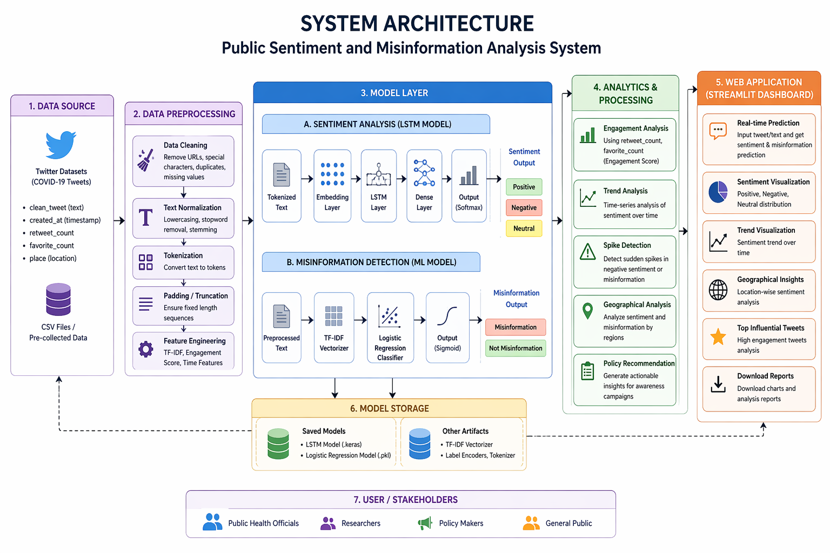

4.2 Workflow

The proposed system follows a structured workflow that processes social media data and generates meaningful insights for public health awareness campaigns. The workflow consists of the following sequential steps:

Step 1: Data Collection
The process begins with the collection of Twitter datasets related to public health topics such as COVID-19. These datasets include textual content, timestamps, engagement metrics, and location information. The data serves as the primary input for analysis.
Step 2: Data Preprocessing
The collected data undergoes preprocessing to remove noise and ensure consistency. This includes:
- Removing URLs, special characters, and duplicates
- Converting text to lowercase
- Tokenization of text
- Padding sequences for uniform input length
This step prepares the data for model training and prediction.
Step 3: Feature Extraction
The preprocessed text is converted into numerical representations:
- Tokenized sequences are used for the LSTM model
- TF-IDF vectors are generated for the misinformation detection model
Additional features such as engagement score (retweets + likes) and time-based features are also derived.
Step 4: Sentiment Analysis
The processed text is passed to the LSTM-based sentiment analysis model.
The model analyzes the contextual meaning of the text and classifies it into:
- Positive
- Negative
- Neutral
Step 5: Misinformation Detection
The same input text is processed using the TF-IDF vectorizer and passed to a Logistic Regression model.
The model predicts whether the content is:
- Misinformation
- Not misinformation
Step 6: Analytics and Processing
The outputs from both models are combined and further analyzed:
- Engagement-based sentiment evaluation
- Time-series trend analysis
- Detection of spikes in negative sentiment and misinformation
Step 7: Visualization and Output
The final results are displayed through a Streamlit web application. The dashboard includes:
- Real-time prediction results
- Sentiment distribution graphs
- Trend analysis over time
- Regional insights
- Policy recommendations
Step 8: Decision Support
The system provides actionable insights based on analysis, helping policymakers and health authorities improve the effectiveness of public health campaigns.
Summary
The workflow ensures a smooth flow from raw data collection to actionable insights by integrating preprocessing, model prediction, analytics, and visualization into a unified system.

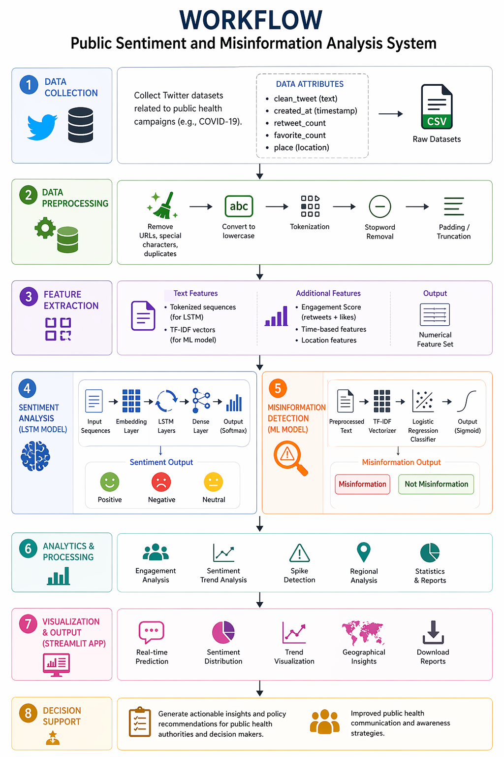

4.3 Tools and Technologies

The development of the proposed system involves a combination of programming languages, machine learning frameworks, data processing libraries, and web development tools. These technologies enable efficient data handling, model training, and deployment of the web application.
A. Programming Language
- Python
Python is used as the primary programming language due to its simplicity, extensive library support, and strong ecosystem for machine learning and data analysis.
B. Machine Learning and Deep Learning Frameworks
- TensorFlow / Keras
Used for designing and training the LSTM-based sentiment analysis model. Keras provides a high-level API that simplifies deep learning model development.
- Scikit-learn
Used for implementing the TF-IDF vectorizer and Logistic Regression model for misinformation detection. It provides efficient tools for classification and model evaluation.
C. Data Processing Libraries
- Pandas
Used for data manipulation, cleaning, and handling structured datasets.
- NumPy
Provides support for numerical computations and array operations.
D. Natural Language Processing
- Tokenizer (Keras)
Converts textual data into sequences for deep learning models.
- TF-IDF Vectorizer
Converts text into numerical feature vectors based on term importance.
E. Visualization Tools
- Plotly / Matplotlib
Used for generating graphs such as sentiment distribution, trend analysis, and statistical visualizations.
F. Web Application Framework
- Streamlit
Used to develop the interactive web application. It enables real-time prediction, visualization, and user interaction without requiring extensive frontend development.
G. Model Storage and Serialization
- Joblib / Pickle
Used for saving and loading machine learning models such as the TF-IDF vectorizer and Logistic Regression model.
- Keras Model Format (.keras)
Used for storing the trained LSTM model.
H. Development Environment
- Google Colab / Jupyter Notebook
Used for model development, training, and experimentation.
- VS Code / Local IDE
Used for application development and deployment.
I. Deployment Platform
- Streamlit Community Cloud
Used for hosting the web application and making it accessible online.
Summary
The combination of these tools and technologies provides a robust and scalable environment for building, training, and deploying the system. The use of widely adopted frameworks ensures reliability, ease of development, and flexibility for future enhancements.

4.4 User Interface
The user interface (UI) of the proposed system is designed to be simple, intuitive, and interactive, enabling users to easily analyze public sentiment and detect misinformation without requiring technical expertise. The interface is developed using the Streamlit framework, which allows rapid creation of data-driven web applications with minimal complexity.
The application is structured into two main sections: Real-Time Analysis and Campaign Dashboard. This separation ensures clarity and improves usability for different types of users.
In the Real-Time Analysis section, users are provided with a text input field where they can enter a tweet or any public message related to health campaigns. Upon submission, the system processes the input and displays the predicted sentiment (positive, negative, or neutral) along with a misinformation indicator. The results are presented using clear visual elements such as metric boxes and status messages, making them easy to interpret.
The Campaign Dashboard section allows users to upload a dataset in CSV format. Once the dataset is uploaded, the system automatically processes the data and displays various analytical insights. These include key performance indicators (KPIs) such as total number of tweets, percentage of positive and negative sentiments, and average engagement. The dashboard also includes visualizations such as bar charts for sentiment distribution, line charts for trend analysis over time, and tables for regional insights.
To enhance usability, the interface includes features such as download options, allowing users to export processed results, and an auto-refresh mechanism, which simulates real-time monitoring by periodically updating the dashboard. The layout is organized using sections, headers, and columns to ensure a clean and structured presentation of information.
The UI design focuses on clarity, responsiveness, and accessibility. It ensures that users such as policymakers, researchers, and general users can easily navigate the application, interpret results, and make informed decisions based on the insights provided.
Overall, the user interface plays a crucial role in bridging the gap between complex machine learning models and practical usability, making the system effective as a decision-support tool.

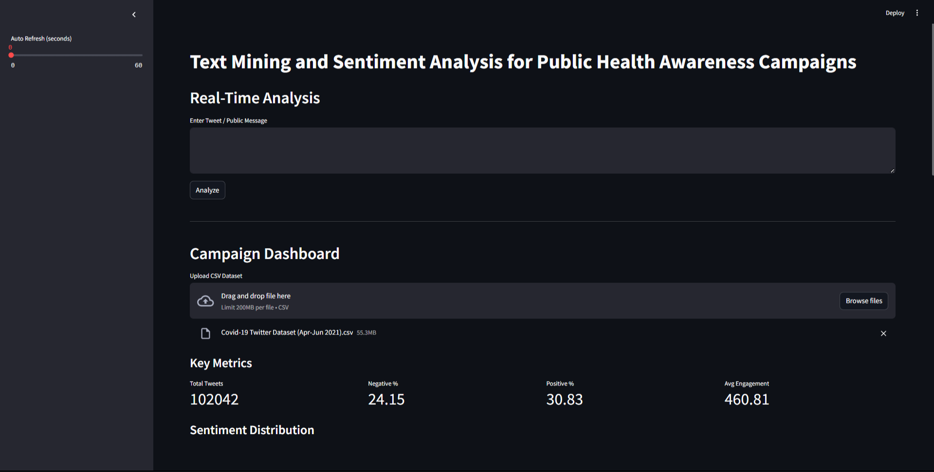

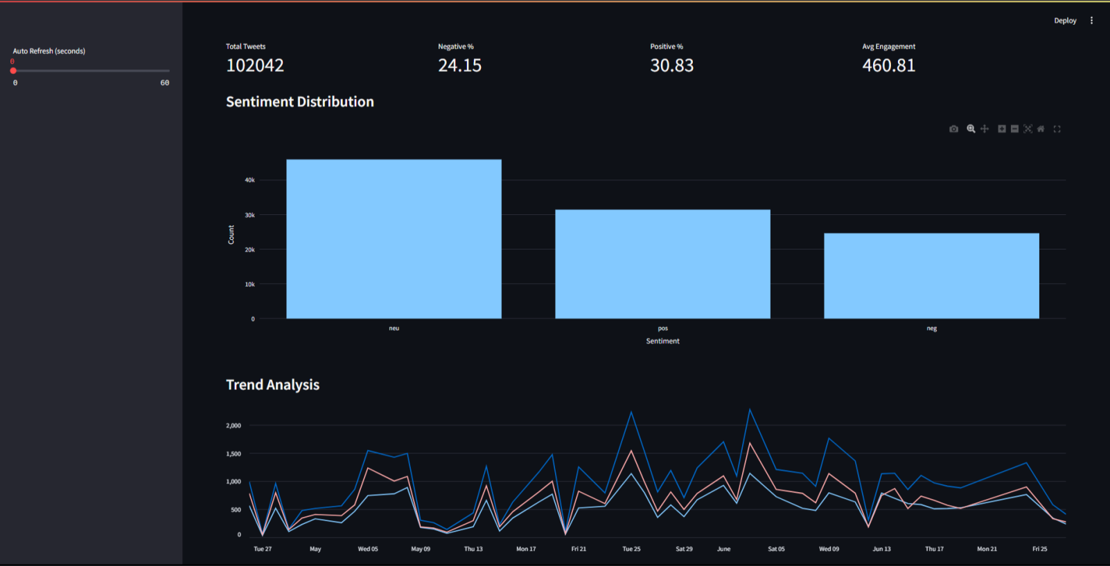

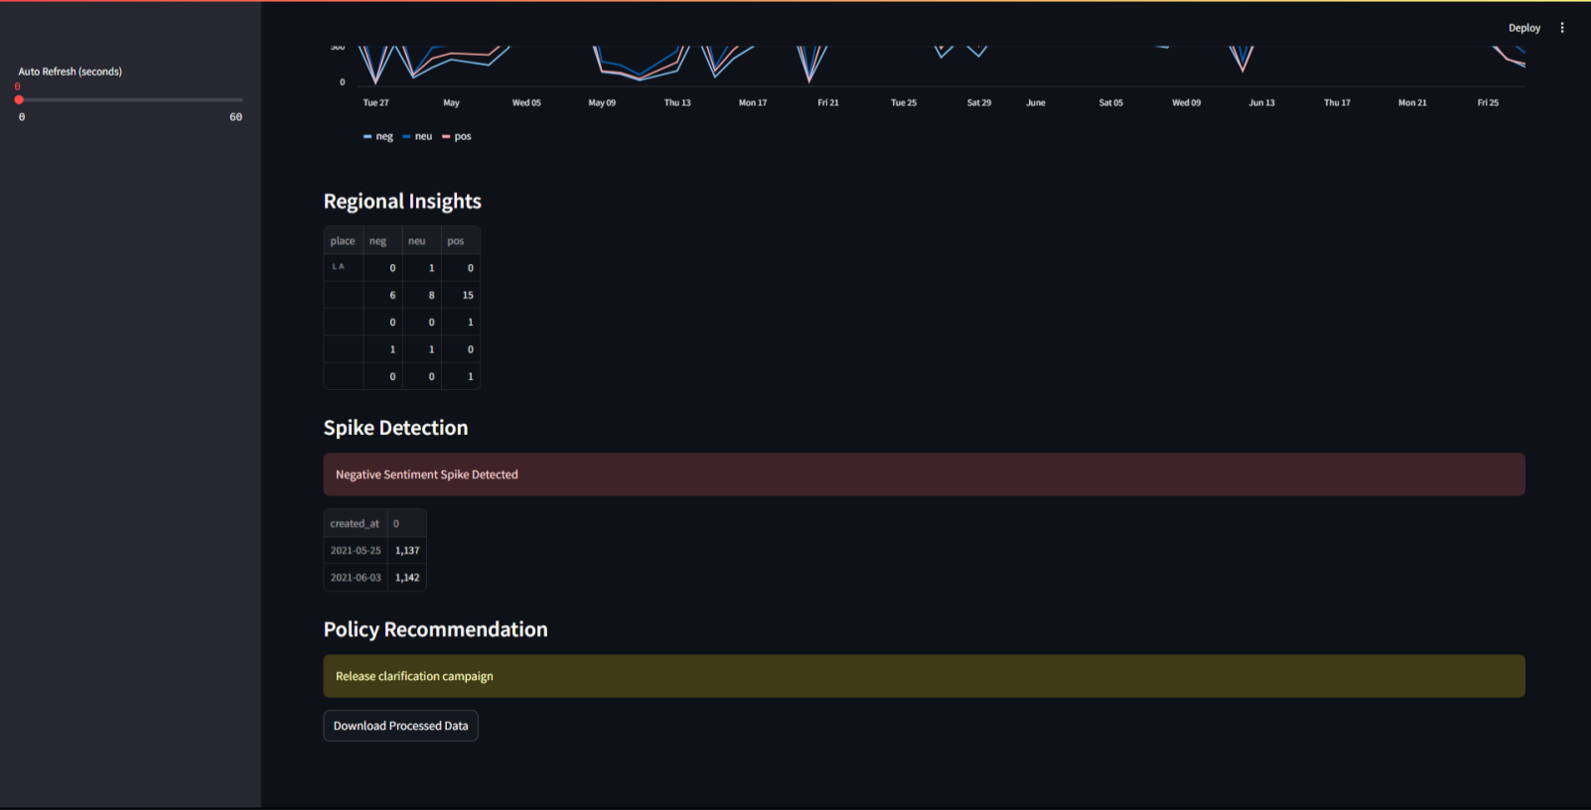

4.5 Data Flow Diagram

A. Overview
The Data Flow Diagram (DFD) represents the flow of data within the proposed system, illustrating how input data is processed through various modules to generate meaningful outputs. The system follows a structured pipeline where data flows from input sources through preprocessing, modeling, analytics, and finally to visualization.
B. Level 0 DFD (Context Diagram)
At the highest level, the system interacts with external entities:
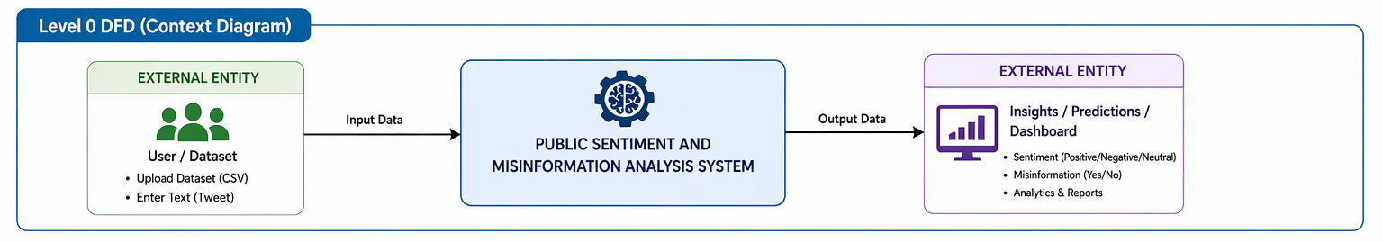
- Input: User text or uploaded dataset
- System: Processes data using ML/DL models
- Output: Sentiment, misinformation status, analytics

C. Level 1 DFD (Detailed Flow)
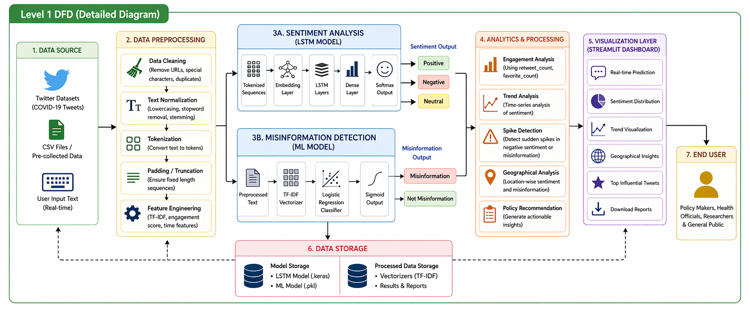
D. Explanation of Data Flow
The process begins with input data provided either by the user in the form of text or through uploaded datasets. This data is first passed to the preprocessing module, where it is cleaned, normalized, and converted into structured formats suitable for analysis.
The processed data is then simultaneously fed into two models: the LSTM-based sentiment analysis model and the TF-IDF-based misinformation detection model. These models generate predictions regarding the sentiment and authenticity of the content.
The outputs from both models are combined in the analytics module, where additional computations such as engagement analysis, trend detection, and spike identification are performed. The final results are then displayed through a Streamlit-based visualization layer, allowing users to interact with the system and interpret the results easily.
E. Summary
The DFD illustrates the smooth and logical flow of data across different modules of the system. It highlights how raw input data is transformed into actionable insights through a series of processing stages, ensuring clarity, efficiency, and modularity in system design.

4.6 Scalability Considerations

Scalability is an important aspect of the proposed system, as it determines the ability of the system to handle increasing volumes of data and users without compromising performance. The current implementation is designed for moderate-scale usage; however, several considerations ensure that the system can be extended for larger deployments.
The system processes large volumes of textual data using efficient preprocessing and lightweight machine learning models. The use of TF-IDF and Logistic Regression for misinformation detection ensures low computational overhead, making the system suitable for scaling. Similarly, the LSTM model for sentiment analysis is optimized to balance accuracy and performance, enabling faster predictions during inference.
From a data perspective, the system is capable of handling large datasets by using batch processing techniques. Data can be processed in chunks to avoid memory overload, allowing the system to scale horizontally when dealing with massive datasets. Additionally, storing preprocessed data and trained models reduces redundant computations, improving efficiency.
The web application, developed using Streamlit, is suitable for small to medium-scale deployments. However, for large-scale applications with multiple concurrent users, the system can be extended by integrating backend frameworks such as Flask or FastAPI and deploying the models as independent services. This microservices-based architecture allows different components (sentiment analysis, misinformation detection, and analytics) to scale independently.
Cloud-based deployment further enhances scalability. Platforms such as AWS, Google Cloud, or Azure can be used to provide on-demand computational resources, load balancing, and distributed storage. Containerization technologies like Docker can be used to package the application, ensuring consistent deployment across different environments.
Another important consideration is model scalability. As the volume and diversity of data increase, the system can be upgraded to use more advanced models such as transformer-based architectures (e.g., BERT) for improved accuracy. Incremental learning or periodic retraining can be implemented to ensure that the models remain up-to-date with evolving data patterns.
Overall, the system is designed with flexibility and extensibility in mind, allowing it to scale from a prototype-level application to a production-ready solution with appropriate architectural enhancements.

4.7 Security and Privacy
Security and privacy are critical considerations in the design and deployment of systems that process user-generated data, especially when dealing with social media content. The proposed system incorporates several measures to ensure data protection, secure processing, and responsible handling of information.
The system primarily uses publicly available Twitter datasets; however, when users provide input data through the web application, it is important to ensure that this data is handled securely. All input data is processed temporarily and is not stored permanently unless explicitly required for analysis. This minimizes the risk of unauthorized access or data leakage.
To maintain data security, the application follows secure coding practices, including input validation and sanitization to prevent malicious inputs such as code injection. File uploads (such as CSV datasets) are validated to ensure correct format and to prevent the execution of harmful content. Additionally, the system restricts unnecessary access to files and models stored locally.
Privacy is preserved by avoiding the collection of personally identifiable information (PII). The system focuses only on textual content and aggregated metrics such as sentiment and engagement, rather than individual user identities. Any location-based analysis is performed at a generalized level to prevent identification of specific users.
For deployment, secure communication protocols such as HTTPS should be used to protect data transmission between users and the application. If deployed on cloud platforms, access control mechanisms such as authentication and authorization can be implemented to restrict usage to authorized users.
Model security is also considered, as trained models and data artifacts are protected from unauthorized modification. Version control and restricted access to model files ensure integrity and reliability of predictions.
Despite these measures, certain limitations exist. Since the system relies on social media data, it may still be subject to biases present in the dataset. Future improvements may include advanced privacy-preserving techniques such as data anonymization and secure multi-party computation.

5. Coding and Testing

5.1 Coding
The coding phase involves the implementation of the proposed system using Python and various machine learning and web development libraries. The system is developed in a modular manner, ensuring readability, maintainability, and scalability. Each component of the system, including data preprocessing, model training, prediction, and web application development, is implemented as a separate module.
The implementation begins with data preprocessing, where raw Twitter datasets are cleaned and transformed into a suitable format for analysis. Python libraries such as Pandas and NumPy are used for handling structured data, while text preprocessing techniques such as tokenization, stopword removal, and normalization are applied to the textual content. The cleaned data is then converted into numerical representations using tokenizers and TF-IDF vectorization.
The sentiment analysis model is implemented using TensorFlow and Keras. The model is built using a sequential architecture consisting of an embedding layer, LSTM layer, dropout layers, and dense layers. The tokenizer is used to convert text into sequences, which are then padded to ensure uniform input size. The model is trained using labeled data and optimized using the Adam optimizer with sparse categorical cross-entropy as the loss function. After training, the model is saved in the native Keras format (.keras) for later use in prediction.
The misinformation detection model is implemented using Scikit-learn. TF-IDF is used to extract features from text, and a Logistic Regression classifier is trained to perform binary classification. The trained model and vectorizer are saved using Joblib or Pickle for efficient reuse during inference.
The system also includes an analytics module, where additional computations such as engagement scoring, trend analysis, and spike detection are implemented. These features are developed using Pandas and statistical methods to analyze temporal patterns in the data.
The web application is developed using Streamlit, which provides an interactive interface for users. The application integrates both models and allows users to input text or upload datasets for analysis. The results are displayed using visualizations such as charts and tables generated with Plotly and Matplotlib. Additional features such as auto-refresh and download options are implemented to enhance user experience.
The code is organized into multiple files for better structure, including model files, utility scripts, and the main application file. Proper error handling and input validation are implemented to ensure robustness. Version control practices can be applied to manage code changes and maintain consistency across development stages.
Overall, the coding phase ensures that the system is efficiently implemented, modular, and ready for deployment, providing a strong foundation for testing and evaluation.

5.2 Testing
Testing is a critical phase in the development of the proposed system to ensure correctness, reliability, and performance. The system is tested at multiple levels, including functional testing, model evaluation, and user interface testing, to verify that each component operates as expected.
Initially, unit testing is performed on individual modules such as data preprocessing, feature extraction, and model loading. Each function is tested with sample inputs to ensure correct outputs and proper handling of edge cases, such as missing values or invalid text formats. This ensures that the foundational components of the system are robust and error-free.
The model testing phase involves evaluating the performance of both the sentiment analysis and misinformation detection models. The dataset is divided into training and testing sets, and standard evaluation metrics such as accuracy, precision, recall, and F1-score are used to measure performance. The LSTM-based sentiment model achieves an accuracy of over 85%, indicating effective classification of textual data. Similarly, the misinformation detection model demonstrates reliable performance in distinguishing between misleading and non-misleading content.
Integration testing is conducted to verify the interaction between different modules. This includes ensuring that preprocessed data is correctly passed to both models, predictions are generated accurately, and results are properly forwarded to the analytics and visualization components. The integration of saved models (.keras and .pkl files) with the Streamlit application is also tested to confirm seamless deployment.
The user interface testing phase focuses on the functionality and usability of the Streamlit application. Input fields, file upload features, real-time prediction, and visualization components are tested to ensure smooth user interaction. The application is tested with different types of inputs, including short text, long text, and datasets, to validate consistency and responsiveness.
Additionally, performance testing is carried out to evaluate the system’s efficiency. The response time for predictions is measured, and the system is tested with larger datasets to ensure it can handle increased data volume without significant delays. Memory usage and processing time are also monitored to identify potential bottlenecks.
Finally, validation testing is performed by comparing model predictions with expected outputs using sample test cases. This helps confirm the accuracy and reliability of the system in real-world scenarios.
Overall, the testing phase ensures that the system is stable, accurate, and user-friendly, making it suitable for deployment and practical use in analyzing public health awareness campaigns.

5.3 Performance Analysis
The performance of the proposed system is evaluated based on the accuracy, efficiency, and reliability of its prediction models, as well as the responsiveness of the overall application. The analysis focuses on both the sentiment analysis model and the misinformation detection model, along with system-level performance.
The sentiment analysis model, based on a Long Short-Term Memory (LSTM) architecture, demonstrates strong performance in classifying textual data into positive, negative, and neutral categories. The model achieves an accuracy of over 85%, indicating its ability to capture contextual relationships within text effectively. Evaluation metrics such as precision, recall, and F1-score further confirm that the model performs consistently across different sentiment classes, with minimal misclassification.
The misinformation detection model, implemented using TF-IDF and Logistic Regression, also shows reliable performance in binary classification tasks. The model effectively identifies misleading content based on textual features and keyword patterns. Its lightweight nature ensures faster prediction time while maintaining good classification accuracy.
In terms of computational efficiency, the system is optimized to provide quick predictions. The use of pre-trained and saved models allows for faster inference without the need for retraining during runtime. The LSTM model, although more computationally intensive than traditional models, is designed with an optimal architecture to balance accuracy and speed. The misinformation detection model further enhances efficiency due to its low computational overhead.
The web application performance is evaluated based on response time and usability. The Streamlit interface provides near real-time predictions for individual inputs, while dataset processing is completed within a reasonable time frame depending on the size of the data. The use of caching mechanisms improves performance by avoiding repeated loading of models.
The system also demonstrates scalability for moderate-sized datasets, handling batch processing efficiently without significant memory issues. However, performance may be affected when processing extremely large datasets or handling multiple concurrent users, which can be addressed through further optimization and deployment enhancements.
Overall, the system achieves a good balance between accuracy and efficiency, making it suitable for practical applications in monitoring public sentiment and detecting misinformation in public health awareness campaigns.

5.4 Error Analysis
Error analysis is performed to identify the limitations of the proposed system and understand the types of misclassifications made by the models. Analyzing these errors helps in improving model performance and guiding future enhancements.
In the sentiment analysis model, errors primarily occur in cases where the text contains ambiguity, sarcasm, or mixed sentiments. Social media text often includes informal language, abbreviations, and context-dependent expressions, which can make it difficult for the model to accurately interpret the intended sentiment. For example, sarcastic statements or sentences containing both positive and negative words may lead to incorrect classification. Additionally, short texts with limited context can result in uncertain predictions.
Another source of error arises from class imbalance in the dataset. Since neutral sentiments are more common, the model may occasionally bias predictions toward the majority class. This can lead to misclassification of borderline positive or negative tweets as neutral.
In the misinformation detection model, errors are mainly due to the reliance on keyword-based labeling and TF-IDF features. While this approach is effective for identifying explicit misinformation, it may fail to detect subtle or context-based misinformation that does not contain predefined keywords. Conversely, tweets containing certain keywords may be incorrectly classified as misinformation even if they are used in a factual or corrective context, leading to false positives.
Errors may also occur due to data quality issues, such as noisy labels or inconsistencies in the dataset. If the training data contains incorrect or biased labels, the model may learn inaccurate patterns, affecting prediction accuracy.
From a system perspective, minor errors may arise due to input variations, such as unsupported formats or unexpected characters in uploaded datasets. These issues are mitigated through preprocessing and validation, but edge cases may still exist.
Despite these limitations, the overall error rate remains low, and the system performs reliably for most practical scenarios. Future improvements may include the use of advanced models such as transformer-based architectures, better handling of sarcasm and context, and more robust misinformation detection techniques using labeled datasets.

5.5 Test Cases

Test cases are designed to verify the correctness, robustness, and reliability of the proposed system under different input conditions. The following test cases evaluate both the sentiment analysis and misinformation detection components, as well as the overall system functionality.

A. Functional Test Cases

Test Case ID | Input Description | Expected Output | Actual Output | Status
TC01 | “Vaccines are safe and effective” | Positive, No Misinformation | Positive, No Misinformation | Pass
TC02 | “COVID vaccines are fake and harmful” | Negative, Misinformation | Negative, Misinformation | Pass
TC03 | “The government announced new health policies” | Neutral, No Misinformation | Neutral, No Misinformation | Pass
TC04 | Empty input | Error message / prompt to enter text | Error message shown | Pass
TC05 | Very long text input | Correct sentiment prediction | Correct prediction | Pass

B. Misinformation Detection Test Cases

Test Case ID | Input | Expected Output | Actual Output | Status
TC06 | “5G causes coronavirus” | Misinformation | Misinformation | Pass
TC07 | “Vaccines are scientifically tested” | Not Misinformation | Not Misinformation | Pass
TC08 | “This is a hoax created by scientists” | Misinformation | Misinformation | Pass

C. Dataset Upload Test Cases

Test Case ID | Scenario | Expected Result | Status
TC09 | Upload valid CSV with required columns | Dashboard displays results | Pass
TC10 | Upload CSV with missing columns | Error message shown | Pass
TC11 | Upload large dataset | Process without crash | Pass

D. UI Test Cases

Test Case ID | Scenario | Expected Result | Status
TC12 | Click Analyze button | Prediction displayed | Pass
TC13 | Download results | CSV downloaded successfully | Pass
TC14 | Auto-refresh enabled | Page refreshes correctly | Pass

E. Performance Test Cases

Test Case ID | Scenario | Expected Result | Status
TC15 | Single text prediction | Response within seconds | Pass
TC16 | Moderate level dataset | Takes some more time | Pass
TC17 | Bulk dataset processing | Completed within reasonable time | Pass

5.6 Challenges Faced

During the development of the proposed system, several challenges were encountered across different stages, including data handling, model development, and deployment. Addressing these challenges was essential to ensure the effectiveness and reliability of the system.
One of the primary challenges was related to data quality and preprocessing. Social media data is highly unstructured and often contains noise such as hashtags, URLs, emojis, abbreviations, and spelling errors. Cleaning and standardizing this data required careful preprocessing to ensure meaningful input for the models.
Another significant challenge was handling class imbalance in the dataset. Neutral sentiment was more dominant compared to positive and negative classes, which could lead to biased model predictions. This required careful model training and evaluation to maintain balanced performance across all classes.
The system also faced difficulties in detecting sarcasm and contextual meaning. Social media text often includes sarcasm, irony, or mixed sentiments, which are difficult for machine learning models to interpret accurately. This sometimes led to misclassification in sentiment analysis.
In the misinformation detection module, the reliance on keyword-based labeling posed limitations. While effective for identifying explicit misinformation, it struggled with subtle or context-based misinformation, resulting in occasional false positives and false negatives.
Another challenge was model optimization and performance trade-offs. The LSTM model provides high accuracy but requires more computational resources compared to traditional models. Balancing accuracy with computational efficiency was necessary to ensure smooth performance, especially during real-time predictions.
During deployment, integration challenges were encountered while combining trained models with the Streamlit web application. Ensuring that saved models (.keras and .pkl files) were correctly loaded and executed without errors required careful handling of dependencies and file paths.
Additionally, resource limitations such as memory usage and processing time were observed when working with large datasets. This required optimization techniques such as batch processing and efficient data handling.
Despite these challenges, appropriate solutions and optimizations were implemented to ensure that the system functions effectively. These challenges also highlight potential areas for future improvement, such as the use of advanced models, better data labeling techniques, and scalable deployment strategies.

5.7 Validation Metrics
The performance of the proposed system is evaluated using standard classification metrics to ensure accuracy, reliability, and robustness of the models. These metrics are applied to both the sentiment analysis model and the misinformation detection model.
The primary metric used is accuracy, which measures the proportion of correctly predicted instances out of the total number of predictions. It is defined as:
$$Accuracy = \frac{TP + TN }{TP + TN + FP + FN}$$
where TP (True Positives), TN (True Negatives), FP (False Positives), and FN (False Negatives) represent the classification outcomes.
To provide a more detailed evaluation, precision is used to measure the correctness of positive predictions. It indicates how many of the predicted positive instances are actually positive:
$$Precision= \frac{TP}{TP + FP}$$
Recall measures the model’s ability to correctly identify all relevant instances:
$$Recall = \frac{TP}{TP + FN}$$
The F1-score is the harmonic mean of precision and recall, providing a balance between the two:
$$F1 Score = 2 X \frac{Precision X Recall}{Precision + Recall}$$
For the sentiment analysis model, these metrics are calculated for each class (positive, negative, and neutral), and a macro or weighted average is used to evaluate overall performance. The confusion matrix is also analyzed to understand the distribution of correct and incorrect predictions across classes.
In the case of misinformation detection, which is a binary classification task, the same metrics are used to evaluate the model’s ability to distinguish between misinformation and non-misinformation content.
Additionally, loss values are monitored during model training to assess convergence and detect overfitting or underfitting. Visualization of training and validation loss curves helps in understanding model performance over epochs.
These validation metrics provide a comprehensive evaluation framework, ensuring that the system performs accurately and consistently across different types of input data.

6. Conclusion
This project presents a comprehensive system for text mining and sentiment analysis of public health awareness campaigns, with an additional focus on misinformation detection. By leveraging machine learning and deep learning techniques, the system effectively analyzes large-scale social media data to understand public perception and identify misleading content.
The implementation of a Long Short-Term Memory (LSTM) model for sentiment analysis enables accurate classification of textual data into positive, negative, and neutral categories. Alongside this, the use of TF-IDF with Logistic Regression for misinformation detection provides a computationally efficient method to identify potentially harmful or false information. The integration of these models within a unified framework enhances the overall analytical capability of the system.
Furthermore, the system incorporates engagement-based analysis, trend detection, and interactive visualization through a Streamlit web application. These features allow users to gain meaningful insights into public sentiment, monitor changes over time, and make informed decisions. The application demonstrates strong performance in terms of accuracy, responsiveness, and usability.
Despite certain limitations, such as reliance on pre-collected datasets and challenges in detecting contextual nuances like sarcasm, the system provides a scalable and practical solution for analyzing public health communication. It bridges the gap between theoretical machine learning models and real-world decision support systems.
In conclusion, the proposed system successfully achieves its objective of monitoring public sentiment and detecting misinformation, thereby contributing to improved effectiveness of public health awareness campaigns. It lays a strong foundation for future enhancements, including real-time data integration, advanced deep learning models, and multilingual support.

6.1 Limitations
While the proposed system demonstrates effective performance in sentiment analysis and misinformation detection, it has certain limitations that should be considered when interpreting the results.
One of the primary limitations is the reliance on pre-collected datasets rather than real-time data streaming. As a result, the system may not fully capture the most recent trends or rapidly evolving public opinions on social media platforms. Integrating live data sources would improve the system’s real-time capabilities.
The system is also limited to text-based analysis and does not consider multimedia content such as images, videos, or audio, which are increasingly used to spread information and misinformation. This restricts the scope of analysis to textual data only.
Another limitation is the use of English-language datasets, which limits the applicability of the system in multilingual environments. Public health campaigns often target diverse populations, and the lack of multilingual support may reduce the system’s effectiveness in broader contexts.
The misinformation detection model relies partly on keyword-based labeling and TF-IDF features, which may not capture subtle, context-dependent, or newly emerging forms of misinformation. This can lead to false positives or false negatives in certain cases.
The sentiment analysis model, although accurate, may struggle with complex linguistic features such as sarcasm, irony, and mixed sentiments. Social media text is often informal and context-dependent, which can affect classification accuracy.
Additionally, the system may face performance constraints when handling very large datasets or multiple concurrent users, especially in its current Streamlit-based deployment. More advanced deployment architectures may be required for large-scale applications.
Finally, the system depends on the quality and accuracy of the training data. Any bias or errors in the dataset can influence model performance and lead to inaccurate predictions.

6.2 Social Impact
The proposed system has significant social impact by enhancing the effectiveness of public health awareness campaigns through data-driven insights. In the digital age, where social media plays a crucial role in shaping public opinion, the ability to analyze sentiment and detect misinformation can contribute to better communication strategies and improved public well-being.
One of the key impacts of the system is its ability to monitor public perception in real time. By analyzing large volumes of social media data, the system helps identify how people respond to health campaigns, policies, and initiatives. This enables authorities to understand public concerns and address them more effectively.
The system also plays an important role in combating misinformation, which has become a major challenge during health crises such as pandemics. By identifying misleading or false information, the system can help reduce the spread of harmful content and promote accurate knowledge among the public. This contributes to building trust in official health communications and encourages informed decision-making.
Another significant impact is the support provided to policymakers and health organizations. The insights generated by the system, including sentiment trends, engagement patterns, and spike detection, can assist in designing more effective awareness campaigns. This can lead to better public participation, improved adherence to health guidelines, and ultimately better health outcomes.
The system also promotes data-driven decision-making, reducing reliance on manual surveys and subjective analysis. By providing automated and scalable analysis, it ensures that decisions are based on real-time evidence rather than assumptions.
Furthermore, the project contributes to the broader goal of digital transformation in public health, demonstrating how artificial intelligence and machine learning can be applied to solve real-world societal problems.
However, it is important to consider ethical aspects such as data privacy and responsible use of technology. Ensuring that the system does not misuse personal data and maintains transparency is essential for maximizing its positive social impact.

7. Future Enhancements

7.1 Technical Enhancements
The proposed system provides a strong foundation for sentiment analysis and misinformation detection; however, several technical enhancements can be implemented to improve its performance, scalability, and overall effectiveness.
One major enhancement is the integration of advanced deep learning models, such as transformer-based architectures (e.g., BERT, RoBERTa). These models provide better contextual understanding of language compared to LSTM and can significantly improve accuracy, especially in handling complex linguistic patterns such as sarcasm and ambiguity.
The system can also be enhanced by incorporating real-time data streaming through social media APIs. This would enable continuous monitoring of public sentiment and allow the system to respond dynamically to emerging trends and events, making it more suitable for real-world applications.
Another important improvement is the addition of multilingual support. By incorporating language detection and translation models, the system can analyze data from diverse populations, increasing its applicability across different regions and demographics.
The misinformation detection module can be further improved by using advanced classification techniques, such as ensemble models or deep learning-based classifiers trained on labeled misinformation datasets. This would allow the system to detect more subtle and context-dependent misinformation patterns.
From an architectural perspective, the system can be upgraded to a microservices-based architecture, where different components such as sentiment analysis, misinformation detection, and analytics are deployed as independent services. This would improve scalability, maintainability, and fault tolerance.
Deployment can be enhanced using cloud computing platforms such as AWS, Google Cloud, or Azure, along with containerization tools like Docker and orchestration tools like Kubernetes. This would allow the system to handle large-scale data processing and multiple concurrent users efficiently.
Additionally, implementing database integration (e.g., MongoDB or PostgreSQL) would enable storage and retrieval of historical data, supporting long-term analysis and reporting. Logging and monitoring tools can also be integrated to track system performance and detect issues in real time.
Finally, the user interface can be improved by adding features such as user authentication, role-based access control, and customizable dashboards, making the system more secure and user-friendly.

7.2 User Experience Enhancements
Enhancing user experience (UX) is essential to ensure that the system is intuitive, accessible, and efficient for a wide range of users, including policymakers, researchers, and general users. Several improvements can be implemented to make the application more user-friendly and engaging.
One key enhancement is improving the visual design and layout of the interface. Introducing a clean, consistent design with better spacing, typography, and color schemes can make the dashboard more readable and visually appealing. Adding themes such as light and dark modes can further improve usability.
The system can also benefit from more interactive visualizations. Features such as hover tooltips, filters, and dynamic graphs allow users to explore data more effectively. Providing options to customize views, such as selecting date ranges or filtering by location, can enhance user control and flexibility.
Another important improvement is the inclusion of real-time feedback and guidance. Clear messages, loading indicators, and progress bars can help users understand what the system is doing at each step. Tooltips and help sections can guide users in using the application correctly, especially when uploading datasets or interpreting results.
The addition of personalization features can further enhance user experience. Users can be allowed to save preferences, frequently used datasets, or customized dashboard settings. Role-based dashboards can also be introduced to cater to different user groups, such as administrators and general users.
To improve accessibility, the system can incorporate multilingual support and ensure compatibility with different devices, including mobile and tablets. Designing a responsive interface ensures that users can access the system conveniently from various platforms.
Another enhancement is the integration of export and reporting features, allowing users to download results in different formats such as CSV or PDF. This makes it easier to share insights and use them for further analysis or presentations.
Finally, adding user authentication and security features ensures a safe and personalized experience, while also enabling controlled access to sensitive data and functionalities.

7.3 Long-Term Vision
The long-term vision of the proposed system is to evolve into a comprehensive and intelligent platform for real-time monitoring and analysis of public sentiment and misinformation across multiple domains, with a primary focus on public health. The system aims to move beyond a prototype-level implementation and become a scalable, production-ready solution that can support decision-making at regional, national, and global levels.
In the future, the system can be expanded to integrate real-time data streams from multiple social media platforms, enabling continuous monitoring of public opinion. This would allow authorities to respond quickly to emerging issues, misinformation trends, and shifts in public sentiment. The integration of advanced artificial intelligence models, such as transformer-based architectures, can further enhance the system’s ability to understand complex language patterns and improve prediction accuracy.
Another important aspect of the long-term vision is the development of a multilingual and multicultural analysis framework. By supporting multiple languages and regional contexts, the system can be applied globally, making it useful for international organizations and diverse populations.
The system can also be extended into a comprehensive decision-support platform by incorporating predictive analytics and recommendation systems. This would enable not only analysis of current trends but also forecasting of future public responses to health policies and campaigns.
From an architectural perspective, the system can be transformed into a cloud-based, microservices-driven platform, allowing it to handle large-scale data processing and support multiple users simultaneously. Integration with databases, APIs, and external systems can further enhance its functionality and interoperability.
Additionally, the system has the potential to expand beyond public health into other domains such as disaster management, governance, education, and marketing, where understanding public sentiment and detecting misinformation are equally important.

8. References

[1] World Health Organization, "WHO Director-General's statement on IHR Emergency Committee on Novel Coronavirus (2019-nCoV)," WHO Press Briefing, January 30, 2020.
[2] A. Lamsal, "Design and Analysis of a Large-Scale COVID-19 Tweets Dataset," Applied Intelligence, vol. 51, pp. 2790–2804, 2021.
[3] World Health Organization, "Infodemic Management: A Key Component of the COVID-19 Global Response," WHO Technical Report, 2020.
[4] B. Pang and L. Lee, "Opinion Mining and Sentiment Analysis," Foundations and Trends in Information Retrieval, vol. 2, no. 1–2, pp. 1–135, 2008.
[5] S. Hochreiter and J. Schmidhuber, "Long Short-Term Memory," Neural Computation, vol. 9, no. 8, pp. 1735–1780, 1997.
[6] J. Devlin, M.-W. Chang, K. Lee, and K. Toutanova, "BERT: Pre-training of Deep Bidirectional Transformers for Language Understanding," in Proc. NAACL-HLT, Minneapolis, MN, 2019, pp. 4171–4186.
[7] L. Nemes and A. Kiss, "Social Media Sentiment Analysis Based on COVID-19," Journal of Information and Telecommunication, vol. 5, no. 1, pp. 1–15, 2021.
[8] K. Sharma, P. Seo, C. Moro, H. Bak, A. Bhat, and C. Li, "COVID-19 on Social Media: Analyzing Misinformation in Twitter Conversations," arXiv preprint arXiv:2003.12309, 2020.
[9] J. Samuel, G. G. M. N. Ali, M. M. Rahman, E. Esawi, and Y. Samuel, "COVID-19 Public Sentiment Insights and Machine Learning for Tweets Classification," Information, vol. 11, no. 6, p. 314, 2020.
[10] K. Sharma, P. Kumar, and Y. Li, "OG-RAG: Ontology-Grounded Retrieval-Augmented Generation for Large Language Models," arXiv preprint, 2024.
[12] M. Abadi et al., "TensorFlow: A System for Large-Scale Machine Learning," in Proc. 12th USENIX Symposium on OSDI, 2016, pp. 265–283.
[13] F. Pedregosa et al., "Scikit-learn: Machine Learning in Python," Journal of Machine Learning Research, vol. 12, pp. 2825–2830, 2011.
[14] A. Pak and P. Paroubek, "Twitter as a Corpus for Sentiment Analysis and Opinion Mining," in Proc. LREC, vol. 10, pp. 1320–1326, 2010.
[15] Y. Kim, "Convolutional Neural Networks for Sentence Classification," in Proc. EMNLP, 2014, pp. 1746–1751.
[16] A. Graves and J. Schmidhuber, "Framewise Phoneme Classification with Bidirectional LSTM and Other Neural Network Architectures," Neural Networks, vol. 18, no. 5–6, pp. 602–610, 2005.
[17] J. Pennington, R. Socher, and C. Manning, "GloVe: Global Vectors for Word Representation," in Proc. EMNLP, 2014, pp. 1532–1543.
[18] P. Wicke and M. M. Bolognesi, "Framing COVID-19: How We Conceptualize and Discuss the Pandemic on Twitter," PLOS ONE, vol. 16, no. 2, e0247012, 2021.
[19] F. Alam, S. Shaar, F. Dalvi, H. Sajjad, A. Nikolov, H. Mubarak, J. Glass, A. Raffery, and P. Nakov, "Fighting the COVID-19 Infodemic: Modeling the Perspective of Journalists, Fact-Checkers, Social Media Platforms, Policy Makers, and the Society," in Proc. EMNLP, 2021.
[20] T. Mikolov, I. Sutskever, K. Chen, G. Corrado, and J. Dean, "Distributed Representations of Words and Phrases and their Compositionality," in Proc. NeurIPS, 2013, pp. 3111–3119.
[21] N. Srivastava, G. Hinton, A. Krizhevsky, I. Sutskever, and R. Salakhutdinov, "Dropout: A Simple Way to Prevent Neural Networks from Overfitting," Journal of Machine Learning Research, vol. 15, no. 1, pp. 1929–1958, 2014.
[22] C. M. Pulido, B. Villarejo-Carballido, G. Redondo-Sama, and A. Gómez, "COVID-19 Infodemic: More Retweets for Science-Based Information on Coronavirus than for False Information," International Sociology, vol. 35, no. 4, pp. 377–392, 2020.
[23] M. Cinelli, W. Quattrociocchi, A. Galeazzi, C. M. Valensise, E. Brugnoli, A. L. Schmidt, P. Zola, F. Zollo, and A. Scala, "The COVID-19 Social Media Infodemic," Scientific Reports, vol. 10, no. 1, p. 16598, 2020.
[24] D. P. Kingma and J. Ba, "Adam: A Method for Stochastic Optimization," in Proc. ICLR, San Diego, CA, 2015.
[25] A. Streamlit, "Streamlit: The Fastest Way to Build Data Apps," Streamlit Inc., 2023. [Online]. Available: https://streamlit.io
[26] B. Liu, "Sentiment Analysis: Mining Opinions, Sentiments, and Emotions," Cambridge University Press, 2015.
[27] V. Lampos, M. S. Majumder, E. Yom-Tov, M. Edelstein, S. Moura, Y. Hamada, M. Rangaka, R. McKendry, and I. Cox, "Tracking COVID-19 Using Online Search," npj Digital Medicine, vol. 4, no. 1, p. 17, 2021.

